Training Design: Spotlight on Blended Learning
While the term ‘Blended Learning’ may have just been coined in recent years, the concept has actually been around for centuries. It is within human nature to be a blended learner, to gain knowledge and experience via multiple avenues. From hunter-gatherer societies, we have been combining firsthand experience with knowledge that is communicated in order to make the best possible judgments and decisions about our environment. While this is a very primitive way of explaining ‘Blended Learning,’ in today’s learning culture it has taken on a much more sophisticated meaning.
The fact is, though, that there are multiple definitions of Blended Learning, and they changes lightly depending on who exactly you’re talking to. Here’s a short list of descriptions you can find by doing a simple Google search:
• Learning events that combine aspects of online and face-to-face instruction. esut.edu.ng/Glossary%20B.html
• A Learning approach that includes the use of appropriate combinations of information technologies--videoconferencing, audio-conferencing, Internet, CD-ROM, and other media, combined with appropriate learning technologies, on-site facilitated activities, and strong learner support systems. web.worldbank.org
• An educational formation that integrates elearning techniques including online delivery of materials through web pages, discussion boards and/or email with traditional teaching methods including lectures, in-person discussions, seminars, or tutorials.
www.teach-nology.com/glossary/terms/b/

For the most part, Blended Learning today refers to training or instruction that combines technological techniques with face-to-face or on-the-job training in order to maximize knowledge transfer. It can also refer to the blending of different theories or models of learning, or the blending of different elearning activities.

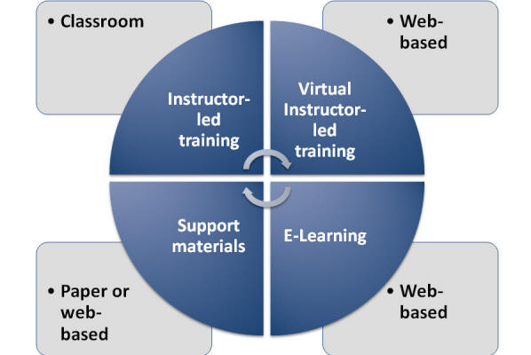

Potential ‘ingredients’ to blend into your learning intervention include, but are not limited to, the following:
Face-to-Face Learning Methods
• Instructor-led classroom training
• Workshops
• Conferences
• Coaching/mentoring
• On-the-job (OTJ) training
• Work teams

Online/Virtual Learning Methods
• Webinars
• Live elearning (Virtual Classrooms)
• Chats and Email
• Immersive technologies
• Discussion Forums
• Online assessments
• Web-based learning modules
• Online resources
• Simulations and virtual labs
• Audio, video, and mobile learning
• Workbooks
• Social media tools (Facebook, Twitter)
Because Blended Learning is primarily context-driven, there is not one specific “best practice” or “recipe” to blend learning techniques and achieve a desired result. Through a proper needs assessment, one can identify the blended learning approach that will provide optimum results for a given audience and purpose. Important points to consider when deciding upon a Blended Learning intervention include learning outcomes or objectives, the design and content of the course, audience/learner analysis – motivation and comfort with multi-media, the degree of collaboration/interaction, the degree of feedback and level of instruction, assessment and evaluation of training, and the role of the instructor/facilitator.

